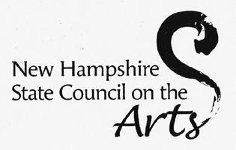
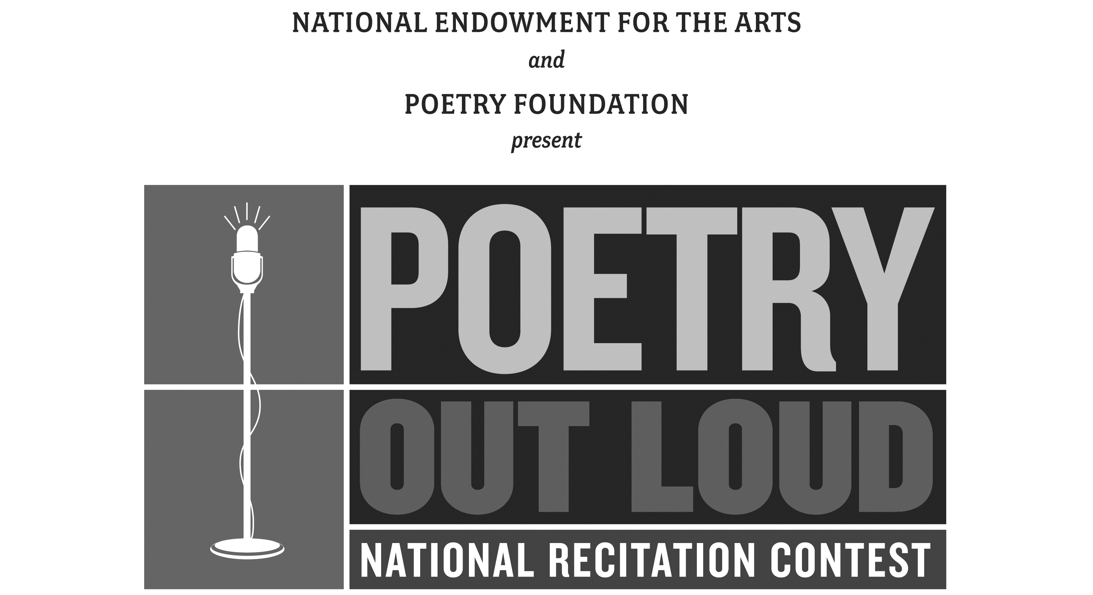
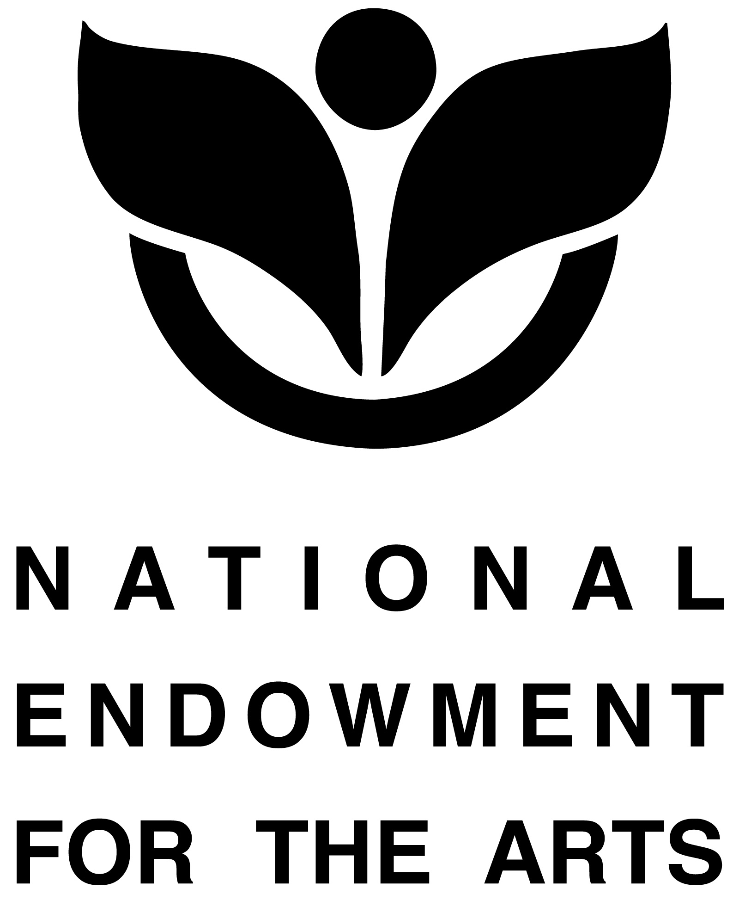

NH Poetry Out Loud 2014
Media Release Form for Students

Please sign, scan, and return via email to Jennifer Andrews at nhpol.assistant@gmail.com.

Date:

I/we __________________________________________________________________

Grant permission for our child: _____________________________________________
(Please print name clearly!)

Age_____________School________________________________________________

To be photographed and recorded as part of the New Hampshire State Poetry Out Loud Events.
Such photos may be used for publicity and archives purposes in the NH Poetry Out Loud Project.

Print parent/guardian's name: ______________________________________________

Signed: _______________________________________________________________
Signature of parent or guardian

